Richard Tirkey 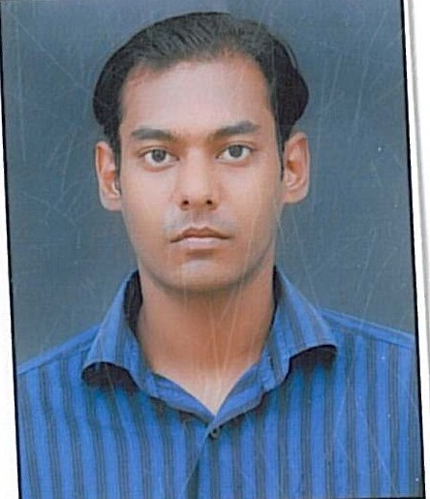

Phone: +91 9928419410
Email: richardtirkey@gmail.com
Objective:
To utilize my skills for development and to work in a highly competitive environment to seek new situations, pursue adaptability, creative exceptional value and maximize my share of experience.
Education:
Post Graduation
Masters in Computer Applications (Hons.), LPU
2009-2012
CGPA (6.22/10)
Graduation
The Oxford college of Science, Bangalore University
2005-2008
Bachelor in Computer Application(B.C.A)
First Division
Senior Secondary
Sh. Maheshwari sr. sec. school, Jodhpur 2003
Second Division
Secondary
Sardar Sr. Sec. school, Jodhpur 2001
Second Division

Work Experiences:
- Operations Executive (Tata Consultancy Services, India Oct 2012 till date).

Achievements:
- Won 2nd in “fighting fears” English play competition, Punjab.
- Won 2nd prize in animates in inter college competition, Bangalore.
- Research paper on cloud computing selected by SUS college nation conference.

Personal Information

Name: Mr. Richard Tirkey
Father’s Name: Mr. Cornelius Tirkey
Date of Birth: November 14, 1984
Nationality: Indian
Marital Status: Married
Language Known: English, Hindi
Permanent Address: 43-B Abhaygarh Scheme Opp., K.V. No. 1
Air Force, Jodhpur (Raj.)
Pin: 342001
Contact number: +91 9928419410

I hereby certify that all the above information is true to the best of my knowledge and belief.

